**SPUMS SYSTEM TECHNICAL GUIDE**

**Prepared by: Khaled Yahya Mohamed Mahmoud ELKarazle**

# Program Flow

All users require a valid account in order to access to the program modules, the chart below shows the flow of the program from login till logout.

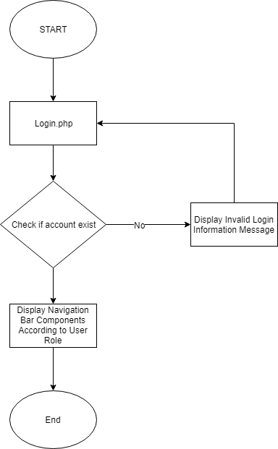

# Program Modules and Functions

* Login.php: To login into the system and decide user privileges.
* Connection.php: To supply the other programs with the database connection.
* Delete_program/user/unit: To remove one user/unit/program from the database
* Edit_user: Allow system administrator and program leaders to edit existing user information
* Dashboard.php: To provide a summary of the system with ability to update users profile
* Register.php: To register a new user (only program leaders and system admins can access to this)
* Units.php: To manage units by viewing, adding and deleting them
* Program.php: To manage programs by viewing, adding and deleting them
* Navbar.php: To provide one consistent navigation bar to the system
* Logout.php: To end the session and logout from the system
* Scripts.js: Contains all the necessary JavaScript codes
* User.php: To provide all information about current system users and system administrators besides program leaders will be able to modify/delete or add users.
* Style.css: To provide simple style for the system

In Addition to the functions mentioned above, bootstrap framework was used for the interface as well as jquery for the add units button in the units module.

# Steps to Use

In order to use the system the first thing that is required to do is running XAMPP server then import the spums.sql database into XAMPP. Furthermore, there are three different accounts, below are the account details alongside with their privileges

|  |  |  |
| --- | --- | --- |
| **Email** | **Password** | **Privilege** |
| [admin@mail.com](mailto:admin@mail.com) | 123 | System Administrator |
| [tstaff@mail.com](mailto:tstaff@mail.com) | 123 | Teaching Staff |
| [pleader@mail.com](mailto:pleader@mail.com) | 123 | Program Leader |